**WEEK-3a**

import java.applet.Applet;

import java.awt.*;

public class Week3aMyApplet extends Applet

{

public void init()

{

setBackground(Color.yellow);

}

public void paint(Graphics g)

{

g.drawString("Hello World",100,100);

}

}

/*

<applet code="Week3aMyApplet.class" width=300

height=300></applet>

*/

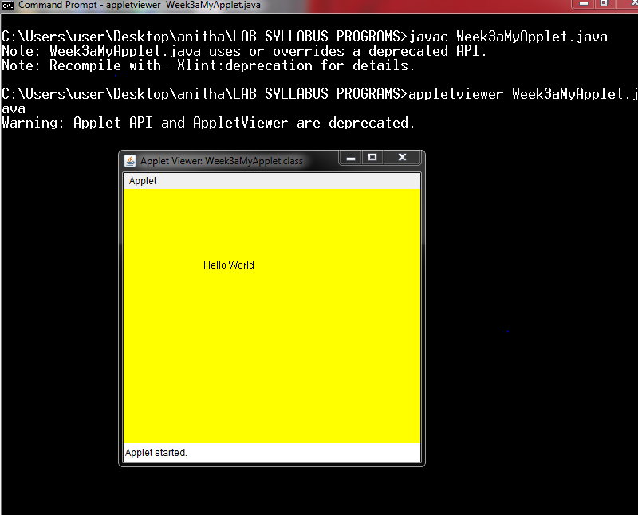

**WEEK-3b**

import java.applet.Applet;

import java.awt.*;

import java.awt.event.*;

public class Week3bFactorial extends Applet

implements ActionListener

{

TextField t1,t2;

Label l1,l2,l3;

Button b;

int fact=1,n,i;

Week3bFactorial e;

public void init()

{

e=this;

t1=new TextField(10);

t2=new TextField(10);

l1=new Label("factorial of a number");

l2=new Label("enter a number");

l3=new Label("result");

b=new Button("compute");

add(l1);

add(l2);

add(t1);

add(b);

add(l3);

add(t2);

b.addActionListener(e);

}

public void actionPerformed(ActionEvent ae)

{

String str=t1.getText();

n=Integer.parseInt(str);

for(i=1;i<=n;i++)

{

fact=fact*i;

}

String msg=""+fact;

t2.setText(msg);

fact=1;

}

}

/*

<applet code="Week3bFactorial.class" width=300

height=300></applet>

*/

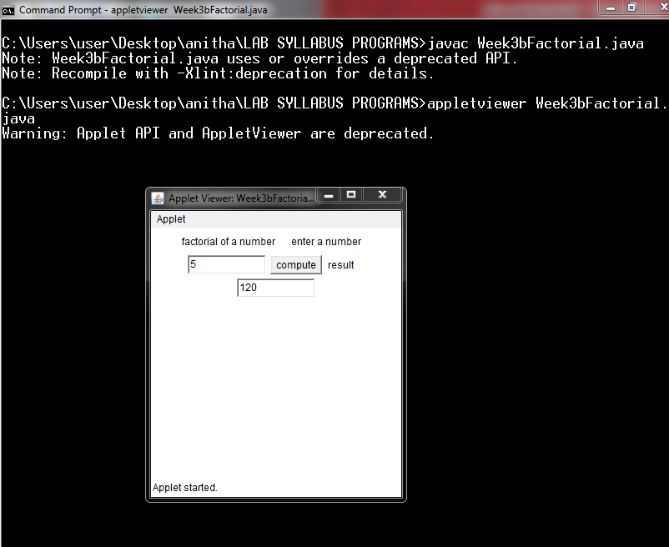

**WEEK-5**

import java.util.Random;

class Thread1 extends Thread

{

public void run()

{

try

{

int num=0;

Random r=new Random();

for(int i=0;i<10;i++)

{

num=r.nextInt(100);

if(num%2==0)

{

Even e=new Even(num);

e.start();

}

else

{

Odd o=new Odd(num);

o.start();

}

Thread.sleep(1000);

}

}

catch(InterruptedException e)

{

System.out.println("handled");

}

}

}

class Even extends Thread

{

int x;

Even(int x)

{

this.x=x;

}

public void run()

{

System.out.println("number is even:"+x+"its square is:"+(x*x));

}

}

class Odd extends Thread

{

int x;

Odd(int x)

{

this.x=x;

}

public void run()

{

System.out.println("number is odd:"+x+"its cube is:"+(x*x*x));

}

}

class Week5MultipleThreadDemo

{

public static void main(String args[])

{

Thread1 t=new Thread1();

t.start();

}

}

OUTPUT:

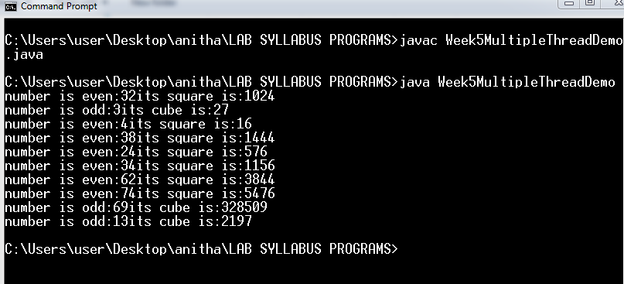

**WEEK-8**

abstract class Shape

{

int dim1;

int dim2;

Shape(int a, int b)

{

dim1 = a;

dim2 = b;

}

Shape(int a)

{

dim1 = a;

}

abstract double printarea(); // printarea is now

an abstract method

}

class Rectangle extends Shape

{

Rectangle (int a, int b)

{ super (a, b);

}

double printarea () // override area for

rectangle

{

System.out.println ("Inside Rectangle.");

return dim1 * dim2;

}

}

class Triangle extends Shape

{

Triangle (int a, int b)

{

super (a, b);

}

double printarea() // override area for triangle

{

System.out.println ("Inside Triangle.");

return dim1 * dim2 / 2;

}

}

class Circle extends Shape

{

Circle(int a)

{

super(a);

}

double printarea()

{

System.out.println("Inside Circle.");

return 3.14*dim1*dim1;

}

}

class Week8AbstractAreas

{

public static void main(String args[])

{

Rectangle r = new Rectangle(9, 5);

Triangle t = new Triangle(10, 8);

Circle c=new Circle(5);

System.out.println("Area of rectangle is :" +

r.printarea());

System.out.println("Area of triangle is :" +

t.printarea());

System.out.println("Area of circle is :" +

c.printarea());

}}

OUTPUT: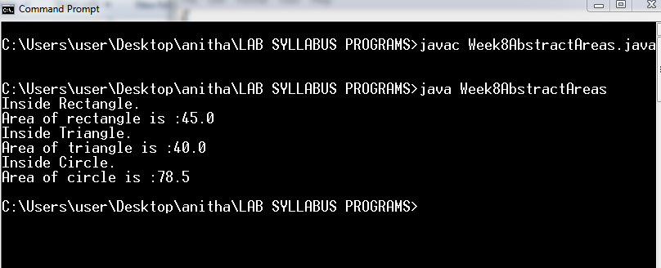

**Week2**

**Calculator**

import java.awt.*;

import java.awt.event.*;

import java.applet.*;

public class Week2Calculator extends Applet

implements ActionListener

{

int p,q,result;

TextField t1;

Button b[]=new Button[10];

Button add,sub,mul,div,clear,mod,EQ;

char OP;

public void init()

{

t1=new TextField(10);

GridLayout gl=new GridLayout(4,5);

setLayout(gl);

for(int i=0;i<10;i++)

{

b[i]=new Button(""+i);

}

add=new Button("+");

sub=new Button("-");

mul=new Button("*");

div=new Button("/");

mod=new Button("%");

clear=new Button("c");

EQ=new Button("=");

t1.addActionListener(this);

add(t1);

for(int i=0;i<10;i++)

{

add(b[i]);

}

add(add);

add(sub);

add(mul);

add(div);

add(mod);

add(clear);

add(EQ);

for(int i=0;i<10;i++)

{

b[i].addActionListener(this);

}

add.addActionListener(this);

sub.addActionListener(this);

mul.addActionListener(this);

div.addActionListener(this);

mod.addActionListener(this);

clear.addActionListener(this);

EQ.addActionListener(this);

}

public void actionPerformed(ActionEvent ae)

{

String str=ae.getActionCommand();

char ch=str.charAt(0);

if ( Character.isDigit(ch)) t1.setText

(t1.getText()+ str);

else if(str.equals("+"))

{

p=Integer.parseInt(t1.getText());

OP='+';

t1.setText("");

}

else if(str.equals("-"))

{

p=Integer.parseInt(t1.getText());

OP='-';

t1.setText("");

}

else if(str.equals("*"))

{

p=Integer.parseInt(t1.getText());

OP='*';

t1.setText("");

}

else if(str.equals("/"))

{

p=Integer.parseInt(t1.getText());

OP='/';

t1.setText("");

}

else if(str.equals("%"))

{

p=Integer.parseInt(t1.getText());

OP='%';

t1.setText("");

}

if(str.equals("="))

{

q=Integer.parseInt(t1.getText());

if(OP=='+')

result=p+q;

else if(OP=='-')

result=p-q;

else if(OP=='*')

result=p* q;

else if(OP=='/')

result=p/q;

else if(OP=='%')

result=p%q;

t1.setText(""+result);

}

if(str.equals("c"))

{

t1.setText("");

}

}

}

/*

<applet code="Week2Calculator.class" width=300

height=300></applet>

*/